**A   
Project report on Login Management System Using Tkinter**



**Objective**

The main objective of the Project on Login Management System is to manage

the details of Username, Password, Email, Changing Password, Permission and

Authorization. It manages all the information about Username, Groups, Permission and Authorization, Username. The project is totally built at administrative end and thus only the administrator is guaranteed the access. The purpose of the project is to build an application program to reduce the manual work for managing the Username, Password, Groups, Email. It tracks all the details about the Email, Changing Password, Permission and Authorization.

Functionalities provided by Login Management System are as follows:

* Provides the searching facilities based on various factors. Such as Username,
* Email, Changing Password, Permission and Authorization
* Password details, Permission and Authorization details, Username.
* It tracks all the information of Password, Groups, Changing Password ect
* Manage the information of Password
* Shows the information and description of the Username, Email
* To increase efficiency of managing the Username, Password
* It deals with monitoring the information and transactions of Changing Password.

**Need of the project**

The old manual system was suffering from a series of drawbacks. Since whole of the system was to be maintained with hands the process of keeping, maintaining and retrieving the information was very tedious and lengthy. The records were never used to be in a systematic order. there used to be lots of difficulties in associating any particular transaction with a particular context. If any information was to be found it was required to go through the different registers, documents there would never exist anything like report generation. There would always be unnecessary consumption of time while entering records and retrieving records. One more problem was that it was very difficult

to find errors while entering the records. Once the records were entered it was very difficult to update these records.

The reason behind it is that there is lot of information to be maintained and have

to be kept in mind while running the business .For this reason we have provided

features Present system is partially automated (computerized), actually existing system is quite laborious as one has to enter same information at three different places.

Following points should be well considered:

* Documents and reports that must be provided by the new system: there can also
* be few reports, which can help management in decision-making and cost
* controlling, but since these reports do not get required attention, such kind of
* reports and information were also identified and given required attention.
* Details of the information needed for each document and report.
* The required frequency and distribution for each document.
* Probable sources of information for each document and report.
* With the implementation of computerized system, the task of keeping records in
* an organized manner will be solved. The greatest of all is the retrieval of information, which will be at the click of the mouse. So the proposed system helps in saving the time in different operations and making information flow easy giving

**Modules of Login System:**

Username Management Module: Used for managing the Username details.

Change Password Module : Used for managing the details of Change Password

Password Management Module: Used for managing the information and details

of the Password.

Login Module : Used for managing the Login details

Register Module : Used for managing the Register informations

Login Module: Used for managing the login details

Users Module : Used for managing the users of the system

**Language :**

* Python
* Tkinter

**Tools To be used**

* Windows 10
* Jupyter Notebook
* VS Studio

**Data Flow Diagram**

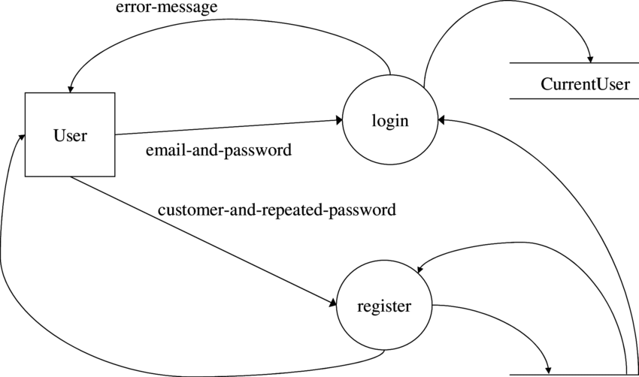

**Expected Out**

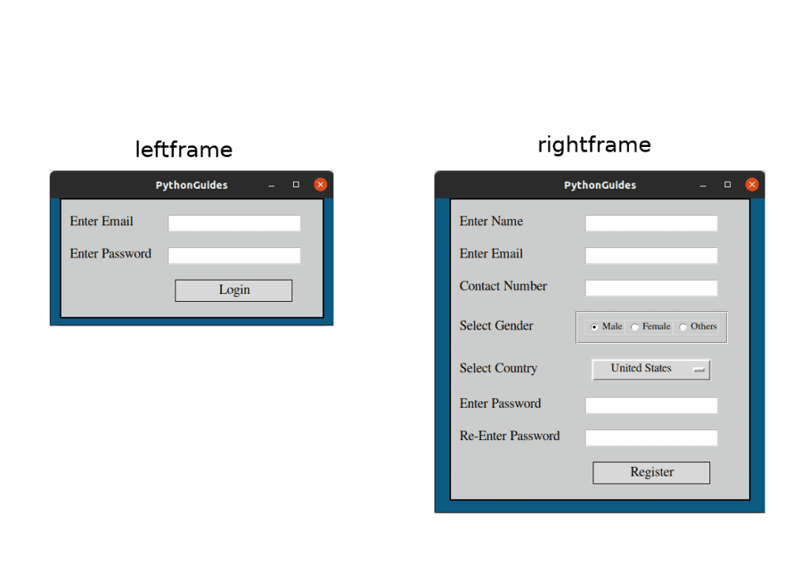

Conclusion of the Project Login Management System:

Our project is only a humble venture to satisfy the needs to manage their project

work. Several user friendly coding have also adopted. This package shall prove to be apowerful package in satisfying all the requirements of the school. The objective of software planning is to provide a frame work that enables the manger to make reasonable estimates made within a limited time frame at the beginning of the software project and should be updated regularly as the project progresses.

At the end it is concluded that we have made effort on following points...

A description of the background and context of the project and its relation to work already done in the area.

Made statement of the aims and objectives of the project.

The description of Purpose, Scope, and applicability.

We define the problem on which we are working in the project.

We describe the requirement Specifications of the system and the actions that

can be done on these things.

We understand the problem domain and produce a model of the system, which

describes operations that can be performed on the system.

We included features and operations in detail, including screen layouts.

We designed user interface and security issues related to system.

References and Bibliography:

Google for problem solving

http://www.javaworld.com/javaworld/jw-01-1998/jw-01-Credentialreview.html

Database Programming with JDBC and Java by O'Reilly

Head First Java 2nd Edition

http://www.jdbc-tutorial.com/

Java and Software Design Concepts by Apress

https://www.tutorialspoint.com/java/

http://www.javatpoint.com/java-tutorial

https://docs.oracle.com/javase/tutorial/

http://www.wampserver.com/en/

http://www.JSP.net/

http://www.tutorialspoint.com